CODE: SPH2

Reg. No.
Ph.D. COURSEWORK EXAMINATION – SEPT/OCT 2023
SUBJECT: AEROSPACE ENGINEERING
SPECIALIZATION PAPER 2
ENERGY AND VARIATIONAL METHODS

Time: 03 hours Maximum Marks: 50
Name: K Selvakumar

Instructions:
- Section A Compulsory

Answer any four from Section B
- Each question carries 10 Marks

SECTION A

Answer the following question: (10 Marks) 1)
- Explain the principal of Virtual work and principle of minimum complimentary Virtual work principle. Give their mathematical statements (5 Marks)

- what are differences between the Galerkin and Rayleigh Ritz methods. Give example of a Beam bending problem to explain the concept.

(5 Marks)

SECTION B

Answer any four from the following question: (Each carrying 10 Marks)

- Solve the following problem using 1 term and 2 term Rayleigh Ritz solution
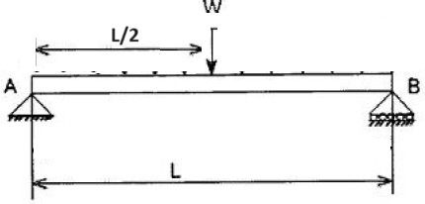

(10 Marks)
- Consider the Functional
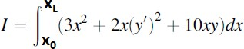

Derive the Euler Lagrange Equations and the Kinematic and Natural Boundary conditions. Discuss the different possible combination of Boundary conditions at the ends x=0 and x=L

(10 Marks)

4) What are Multifield Variational principles. How are they different from Minimum potential energy principle and minimum complimentary energy principle. Give examples of any two multifield variational principles.(10 Marks)

- Use Castigliano first theorem to determine deflection at the midpoint of the Propped cantilever beam shown below.
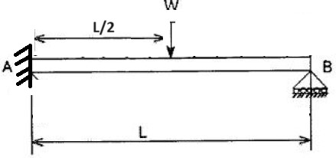

(10 Marks)
- Consider the example of a fixed beam under uniformly distributed load as shown in Figure below. Establish the Governing Differential Equations and the boundary conditions using the principle of Minimum Potential Energy. (10 Marks)
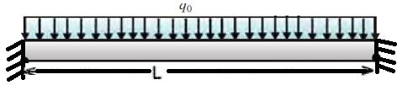
7) .
Explain using an example the strong form and the weak form of the variational function. Discuss the benefits and limitations of both the forms. (10 Marks)

**********

